Exercise 1: Implementing the Singleton Pattern
Scenario:
You need to ensure that a logging utility class in your application has only one instance throughout the application lifecycle to ensure consistent logging.
Code :
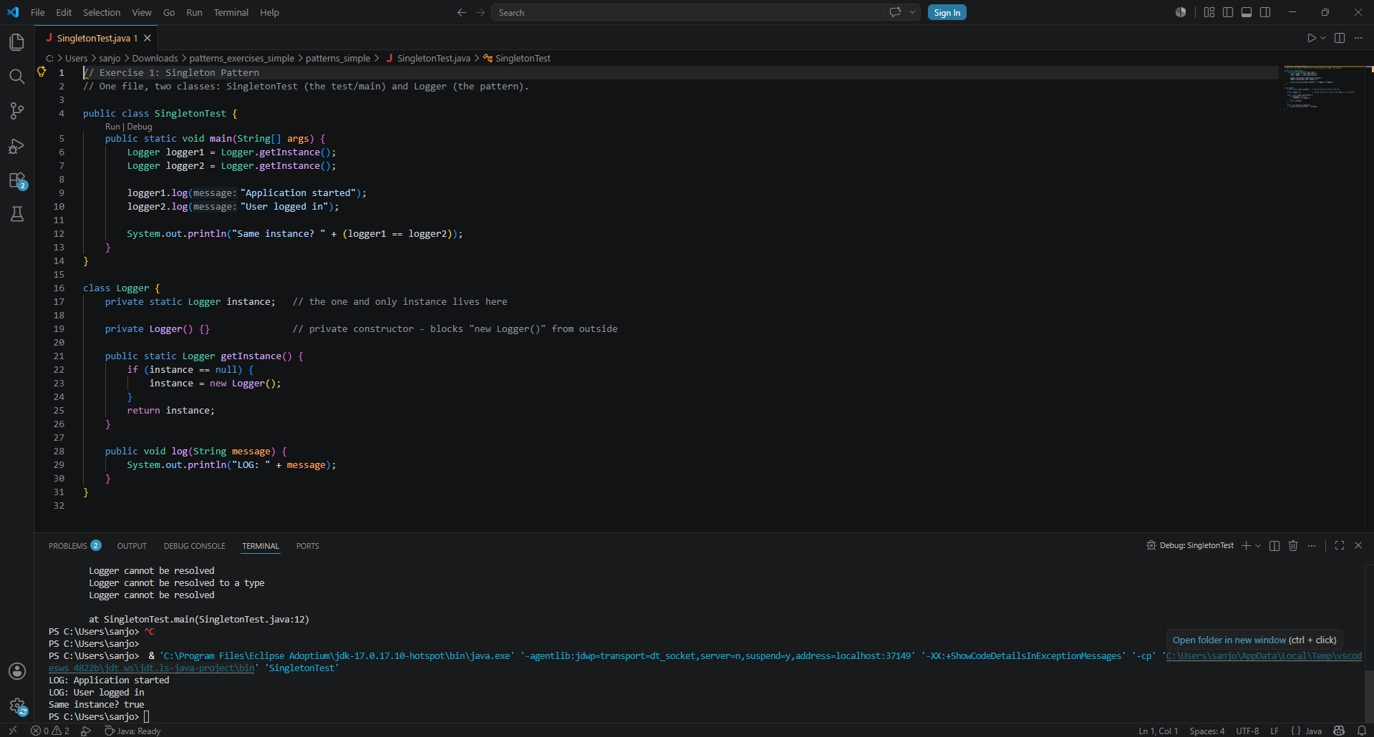

Exercise 2: Implementing the Factory Method Pattern
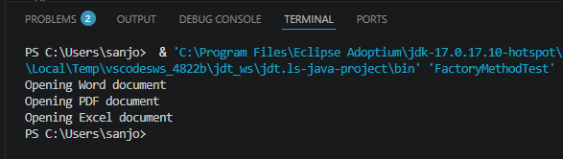
Scenario:
You are developing a document management system that needs to create different types of documents (e.g., Word, PDF, Excel). Use the Factory Method Pattern to achieve this.
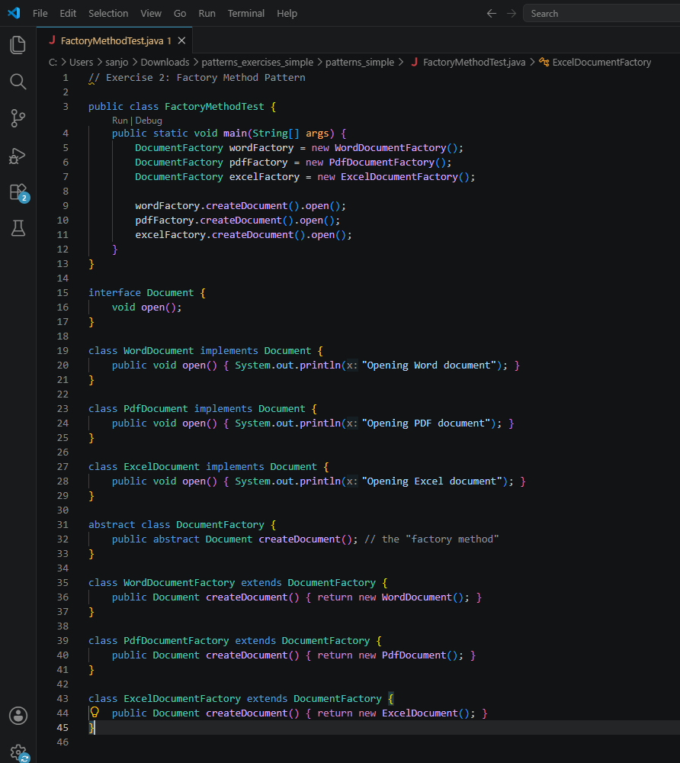

Exercise 3: Implementing the Builder Pattern
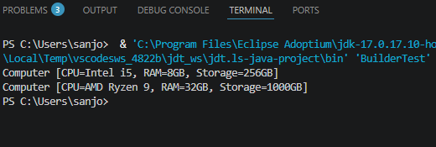
Scenario:
You are developing a system to create complex objects such as a Computer with multiple optional parts. Use the Builder Pattern to manage the construction process.
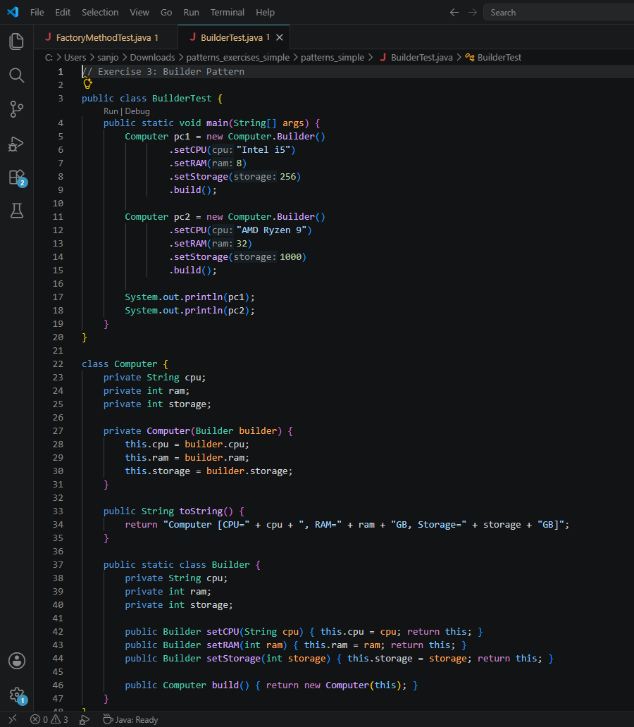

Exercise 4: Implementing the Adapter Pattern
Scenario:
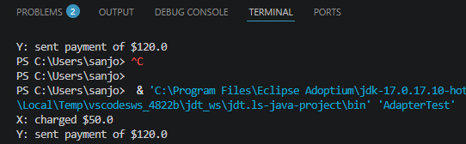
You are developing a payment processing system that needs to integrate with multiple third-party payment gateways with different interfaces. Use the Adapter Pattern to achieve this.

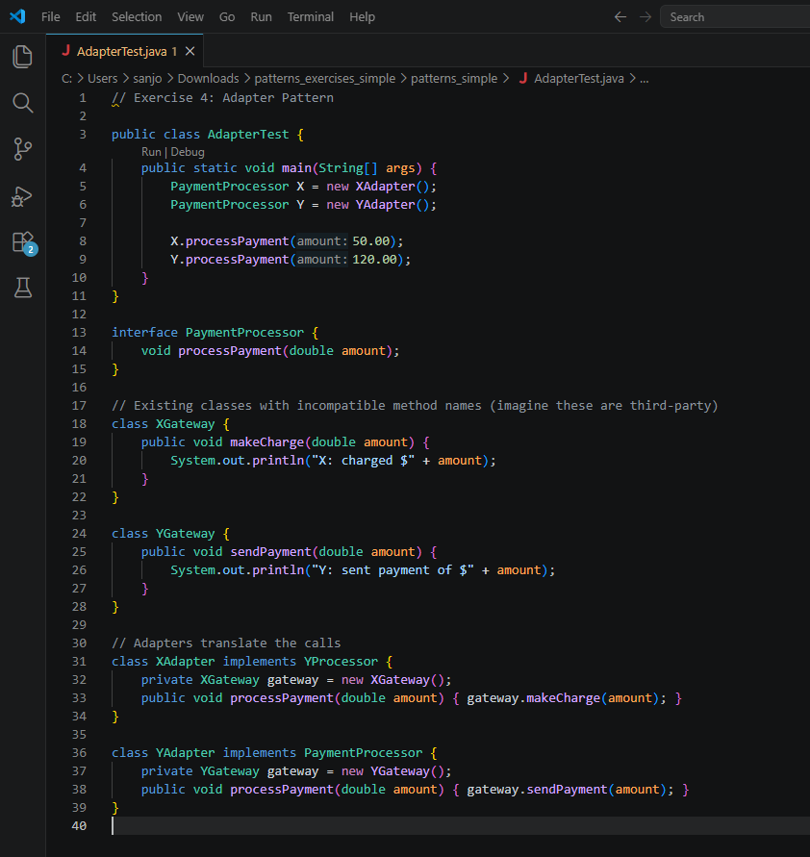

Exercise 5: Implementing the Decorator Pattern
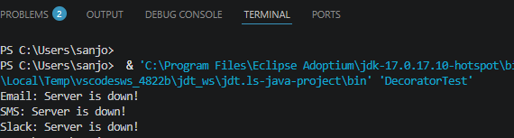
Scenario:
You are developing a notification system where notifications can be sent via multiple channels (e.g., Email, SMS). Use the Decorator Pattern to add functionalities dynamically.
